Take-home Worksheet
Name: |  | Grade:  II° | Date:
Objective: Students will be able to associate short sentences to a broad structure. | Skills: Reading skills, writing skills, skimming, scanning, vocabulary related to Global Issues.
Instructions:
- This worksheet is meant to be made at home.
- Read each instruction carefully so you avoid mistakes.
- Answer this handout using PEN no matter what color.
- You can use online dictionaries to search for words that you do not understand.
- If you have a question, please write your question/doubt to: joaperez90@gmail.com

Activity: First, read the following text about Global Issues (or main topic) and then, assign a short title (the ones of the box) for each paragraph that has a number. ONLY put the letter of the title.
- TIP: At the end of the text, there is a vocabulary with keywords.
What is a Global Issue?
An “issue” is a matter of concern or of interest, and may have a political, social, environmental or economic focus. An example of a political issue is, whether a country becomes a republic. An example of a social issue might be how to reduce violence on the streets.
Issues can also occur on different scales. They can be local or global, according to the area that is affected.
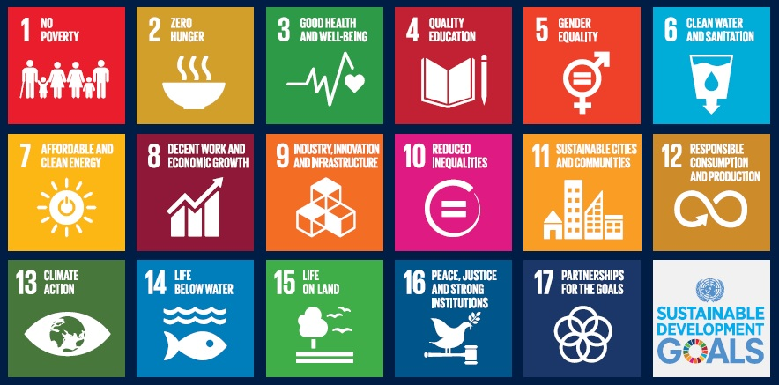
When we talk about a global issue, we are usually referring to something that affects a number of countries and populations. It is an issue that impacts upon or is important to the global community.
Here are some examples of the most important global issues nowadays:

a. Children’s rights
b. Climate change
c. Global food production
d. Globalization
e. Ice shelf boundaries
f. Cultural diversity
g. Sustainability of the planet
h. Water shortage

- ____________ International organizations predict that rising prices for food commodities and increasing fuel prices will lead to an increase in the numbers of hungry people in developing countries over the next decades.

- ____________ Since the early twentieth century, global temperatures have been increasing gradually. There is growing international concern that climate change will impact on the economic, health, safety and security of many countries and their inhabitants.

- ____________ Effective sanitation is important for human health. Exclusion from water and sanitation services on the basis of poverty, ability to pay, group membership or place of habitation is a violation of human rights.

- ____________ Over the past years, scientists have been noticing a rapid disintegration of ice shelves on the Antarctic Peninsula and the northern coast of Canada. This process has had a huge impact on world climate, ocean currents and the wildlife in the area around ice shelves.

- ____________ Humans have traded goods and services since long before recorded history. However, during the last decades, international trade has been increasing significantly due to improved transportation, communication and the integration of country economies.

- ____________ Indigenous peoples have inherited unique social, cultural, economic and political characteristics. The international community has recognized that indigenous peoples are vulnerable and that steps need to be taken to protect their unique cultures.

- ____________ Sustainable development recognizes that future development cannot occur without protection of the world’s natural resources for future generations.

- ____________ In 1989, world leaders decided that people under 18 years old often need special care and protection. A summary of the rights under The Convention on the Rights of the Child can be found at http://www.unicef.org/crc/fi les/Rights_overview.pdf

Key words:
- Boundaries: Límites
- Commodities: Any product that can be sold or traded.
- Concern: Preocupación
- Sanitation: Sanitizar
- Shortage: Escasez
- Sustainable: Sostenible, sustentable
- Trade: Intercambio

@EllieTheWeinerdog

